Table 1. Input fields of offline radiation calculations. The fields with suffix ‘CAM’ are 15-year annual mean outputs from climate simulation with CAM, while the fields with suffix ‘IAP’ are outputs from the IAP model.

Experiment Name | Sensitive Input Fields
Experiment Name | Temperature | Specific Humidity | Cloud Fraction
CAM_ctrl | T_CAM | Q_CAM | CLD_CAM
IAP_ctrl | T_IAP | Q_IAP | CLD_IAP
IAP_CLDonly | T_CAM | Q_CAM | CLD_IAP
IAP_Tonly | T_IAP | Q_CAM | CLD_CAM
IAP_Qonly | T_CAM | Q_IAP | CLD_CAM

Figure Captions

Fig.1. The biases of zonally averaged 15-year annual mean temperature from (a) IAP and (b) CAM simulations with contrast to NCEP reanalysis data, and (c) their difference (IAP - CAM). Contour intervals are 1 K between -3 K and 3 K but 2 K beyond in (a) and (b) and 0.5 K in (c). Shaded areas are statistically significant at 0.05 level from the student-t test.

Fig. 2. Zonally averaged 15-year annual mean zonal wind from (a) IAP , (b) CAM, (c) NCEP reanalysis data, the biases of (d) IAP and (e) CAM with contrast to NCEP reanalysis data, and (f) the difference of the two simulations (IAP - CAM). Contour intervals are 5 m s⁻¹ in (a), (b) and (c), 2 m s⁻¹ in (d) and (e), and 1 m s⁻¹ in (f). Shaded areas are statistically significant at 0.05 level from the student-t test.

Fig. 3. Zonally averaged 15-year annual mean transient eddy heat flux from (a) IAP, (b) CAM, (c) ERA-Interim reanalysis data, and (d) the difference of the two simulations (IAP - CAM). Contour intervals are 3 K m s⁻¹ in (a) and (b), 1 K m s⁻¹ in (c) and (d). Shaded areas are statistically significant at 0.05 level by the Student-t test.

Fig. 4. Same as Fig. 3, but for transient eddy momentum flux. Contour intervals are 10 m² s⁻² in (a) and (b), and 4 m² s⁻² in (c) and (d).

Fig. 5. Differences of zonally averaged 5-year annual mean transient eddy heat flux (a) and momentum flux (b) from the climate simulations between the IAP AGCM4.0 with resolution 1º x 1º and the CAM3.1 with resolution T85 (IAP -CAM). Contour intervals are 1 K m s⁻¹ in (a) and 4 m² s⁻² in (b).

Fig. 6. Zonally averaged 17-periods mean temperature from the Held-Suarez tests with the (a) IAP and (b) CAM dynamical cores, and (c) their difference (IAP - CAM). Contour intervals are 5 K in (a) and (b), 0.5 K in (c). Shaded areas are statistically significant at 0.05 level from the student-t test.

Fig. 7. Same as Fig. 6, but for zonal wind. Contour intervals are 5 m s⁻¹ in (a) and (b), and 1 m s⁻¹ in (c).

Fig. 8. Same as Fig. 6, but for transient eddy heat flux. Contour intervals are 3 K m s⁻¹ in (a) and (b), and 1 K m s⁻¹ in (c).

Fig. 9. Same as Fig. 6, but for transient eddy momentum flux. Contour intervals are 10 m² s⁻² in (a) and (b), and 2 m² s⁻² in (c).

Fig. 10. The difference of zonally averaged annual mean between IAP and CAM from aqua planet tests: (a) temperature; (b) zonal wind; (c) transient eddy heat flux; (d) transient eddy momentum flux. Contour intervals are 0.5 K in (a), 2 m s⁻¹ in (b), 1 K m s⁻¹ in (c), and 3 m² s⁻² in (d).

Fig. 11. Zonally averaged annual mean dynamical transport of moisture from (a) IAP and (b) CAM full-physics experiments with realistic boundary conditions, and (c) their difference (IAP - CAM). Contour values are 5 x10⁻² g kg⁻¹ day⁻¹ in (a) and (b), 1 x10⁻² g kg⁻¹ day⁻¹ in (c).

Fig. 12. Same as Fig. 11, but for relative humidity. Contour values are 10 percent in (a) and (b), 2 percent in (c).

Fig. 13. Cloud fraction used in experiment (a) IAP_CLDonly and (b) CAM_ctrl, and (c) their difference (IAP_CLDonly - CAM_ctrl). Contour values are 0.05 in (a) and (b), 0.02 in (c).

Fig. 14. Zonally averaged annual mean radiative diabatic heating (qrs and qrl for shortwave and longwave radiative heating respectively) rate from (a) IAP and (b) CAM simulations, and (c) their difference (IAP - CAM). Contour intervals are 0.4 K day⁻¹ in (a) and (b), 0.1 K day⁻¹ in (c).

Fig. 15. Differences of radiative diabatic heating rate from the sensitive experiments: (a) IAP_ctrl–CAM_ctrl, (b) IAP_CLDonly–CAM_ctrl, (c) IAP_Tonly–CAM_ctrl, (d) IAP_Qonly–CAM_ctrl. Contour intervals are 0.2 K day⁻¹ in (a) an (b), 0.05 K day⁻¹ in (c) and (d).

Fig. 16. Evolution of heating rate from the IAP model in (a) Held-Suarez test and (b) climate simulation in troposphere (150 hPa – 1000 hPa) at low latitude (30°S - 30°N). Solid square: diabatic heating rate, solid triangle: adiabatic heating rate, hollow circle: total heating rate. Unit: 10⁻⁶ K s⁻¹
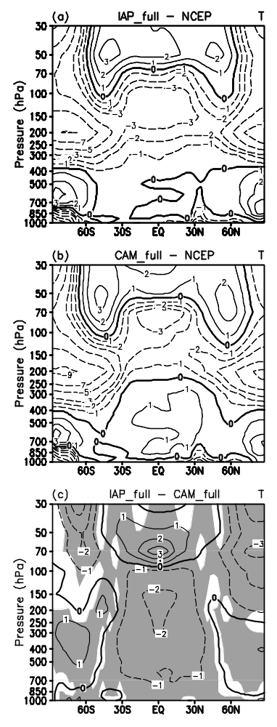
Fig.1. The biases of zonally averaged 15-year annual mean temperature from (a) IAP and (b) CAM simulations with contrast to NCEP reanalysis data, and (c) their difference (IAP - CAM). Contour intervals are 1 K between -3 K and 3 K but 2 K beyond in (a) and (b) and 0.5 K in (c). Shaded areas are statistically significant at 0.05 level from the student-t test.
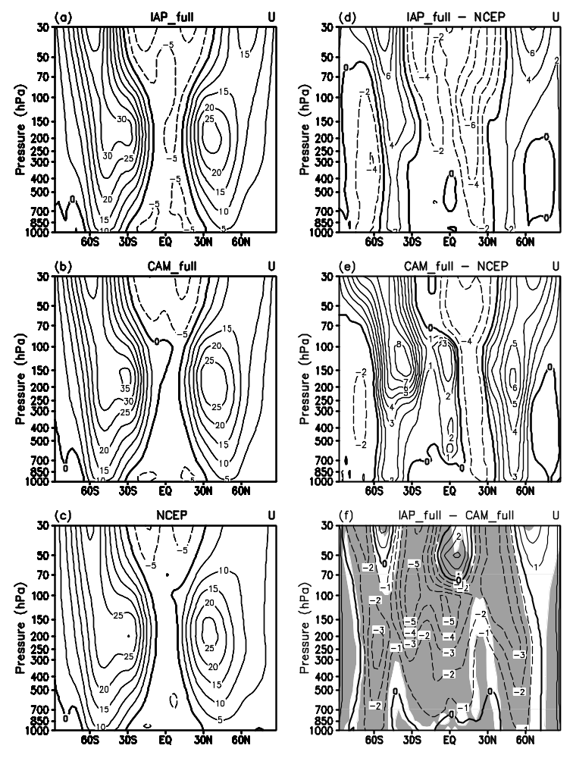
Fig. 2. Zonally averaged 15-year annual mean zonal wind from (a) IAP , (b) CAM, (c) NCEP reanalysis data, the biases of (d) IAP and (e) CAM with contrast to NCEP reanalysis data, and (f) the difference of the two simulations (IAP - CAM). Contour intervals are 5 m s⁻¹ in (a), (b) and (c), 2 m s⁻¹ in (d) and (e), and 1 m s⁻¹ in (f). Shaded areas are statistically significant at 0.05 level from the student-t test.
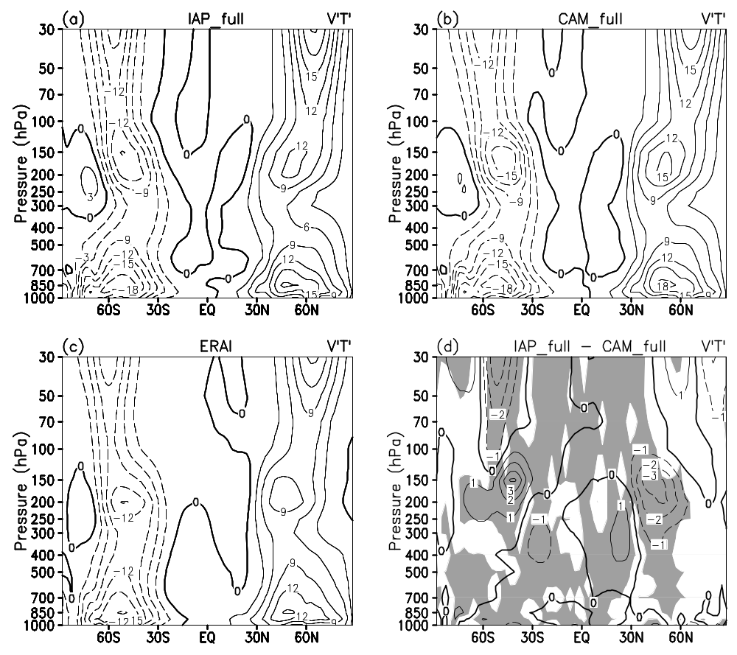

Fig. 3. Zonally averaged 15-year annual mean transient eddy heat flux from (a) IAP, (b) CAM, (c) ERA-Interim reanalysis data, and (d) the difference of the two simulations (IAP - CAM). Contour intervals are 3 K m s⁻¹ in (a) and (b), 1 K m s⁻¹ in (c) and (d). Shaded areas are statistically significant at 0.05 level by the Student-t test.

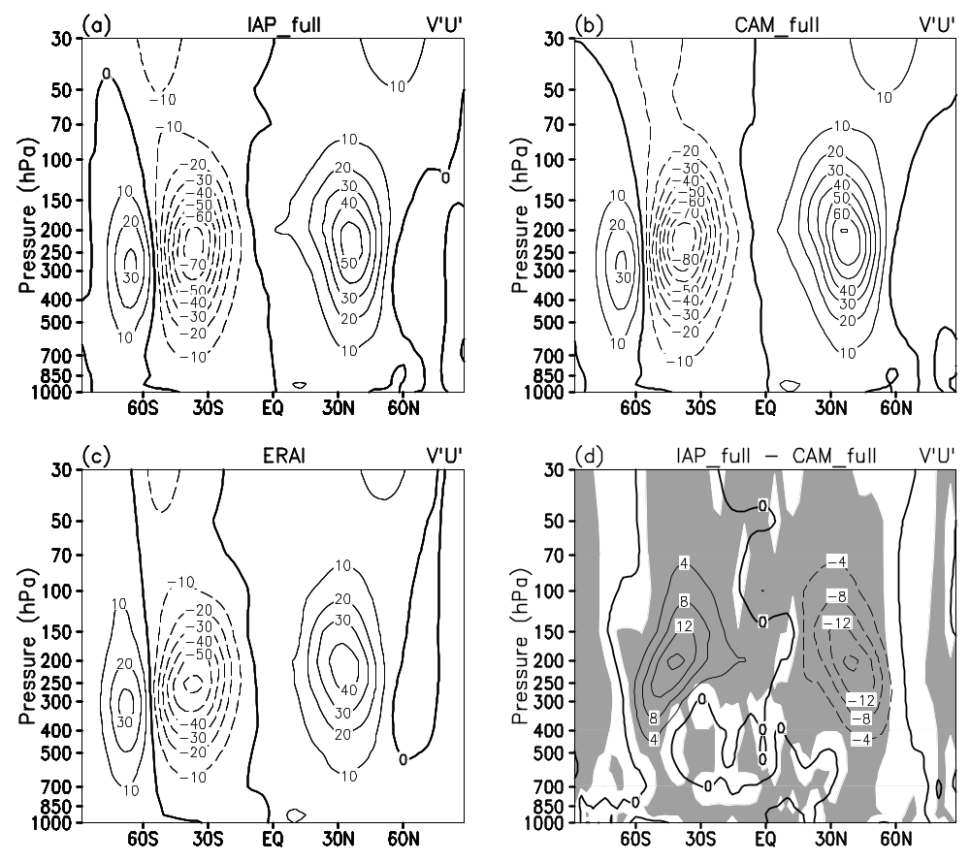
Fig. 4. Same as Fig. 3, but for transient eddy momentum flux. Contour intervals are 10 m² s⁻² in (a) and (b), and 4 m² s⁻² in (c) and (d).

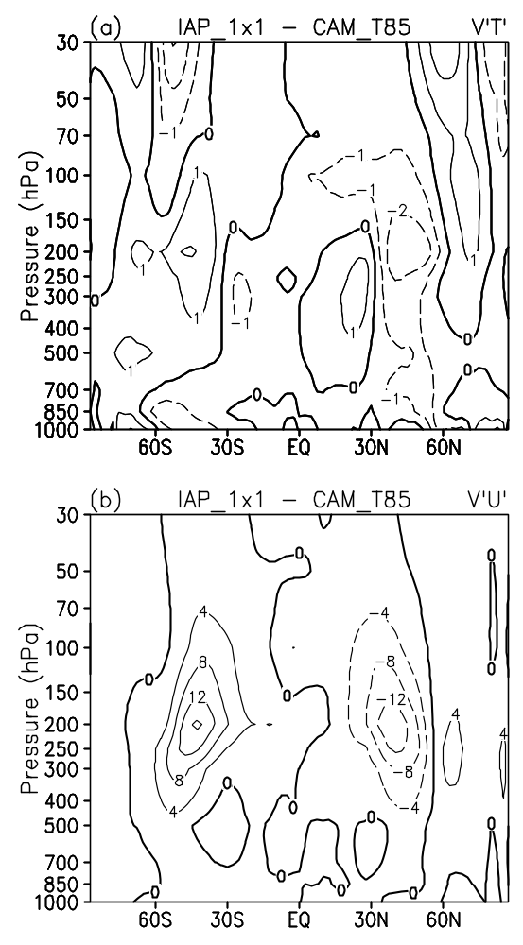
Fig. 5. Differences of zonally averaged 5-year annual mean transient eddy heat flux (a) and momentum flux (b) from the climate simulations between the IAP AGCM4.0 with resolution 1º x 1º and the CAM3.1 with resolution T85 (IAP -CAM). Contour intervals are 1 K m s⁻¹ in (a) and 4 m² s⁻² in (b).
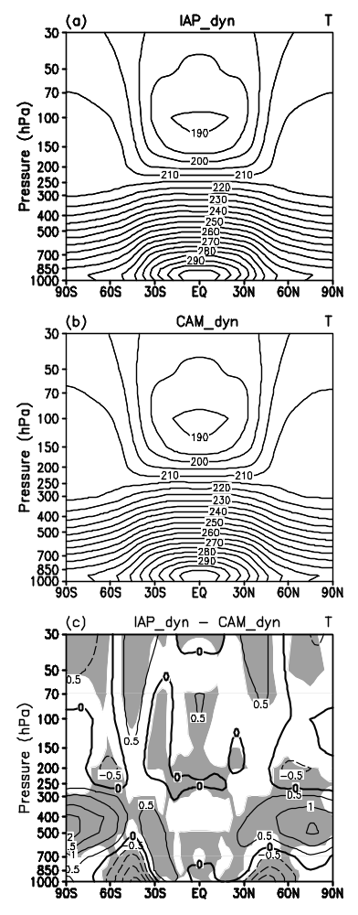
Fig. 6. Zonally averaged 17-periods mean temperature from the Held-Suarez tests with the (a) IAP and (b) CAM dynamical cores, and (c) their difference (IAP - CAM). Contour intervals are 5 K in (a) and (b), 0.5 K in (c). Shaded areas are statistically significant at 0.05 level from the student-t test.

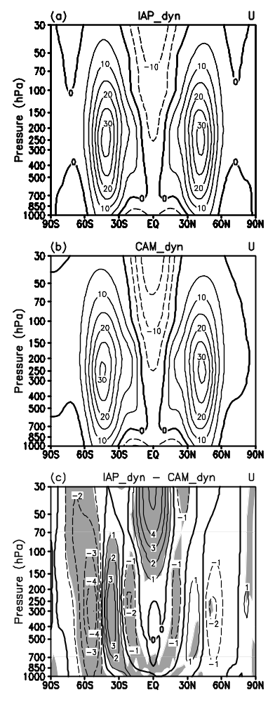
Fig. 7. Same as Fig. 6, but for zonal wind. Contour intervals are 5 m s⁻¹ in (a) and (b), and 1 m s⁻¹ in (c).

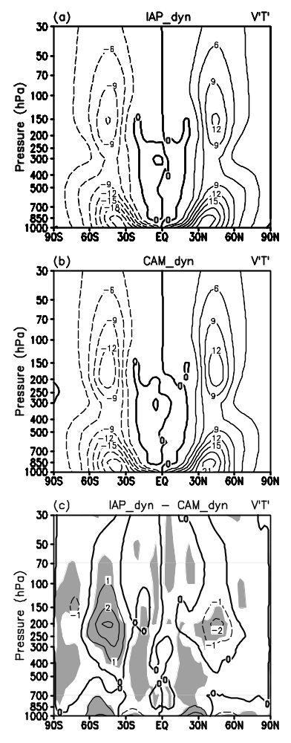
Fig. 8. Same as Fig. 6, but for transient eddy heat flux. Contour intervals are 3 K m s⁻¹ in (a) and (b), and 1 K m s⁻¹ in (c).

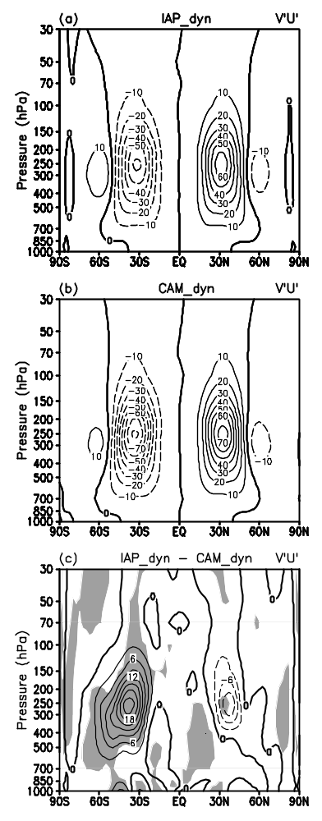
Fig. 9. Same as Fig. 6, but for transient eddy momentum flux. Contour intervals are 10 m² s⁻² in (a) and (b), and 3 m² s⁻² in (c).

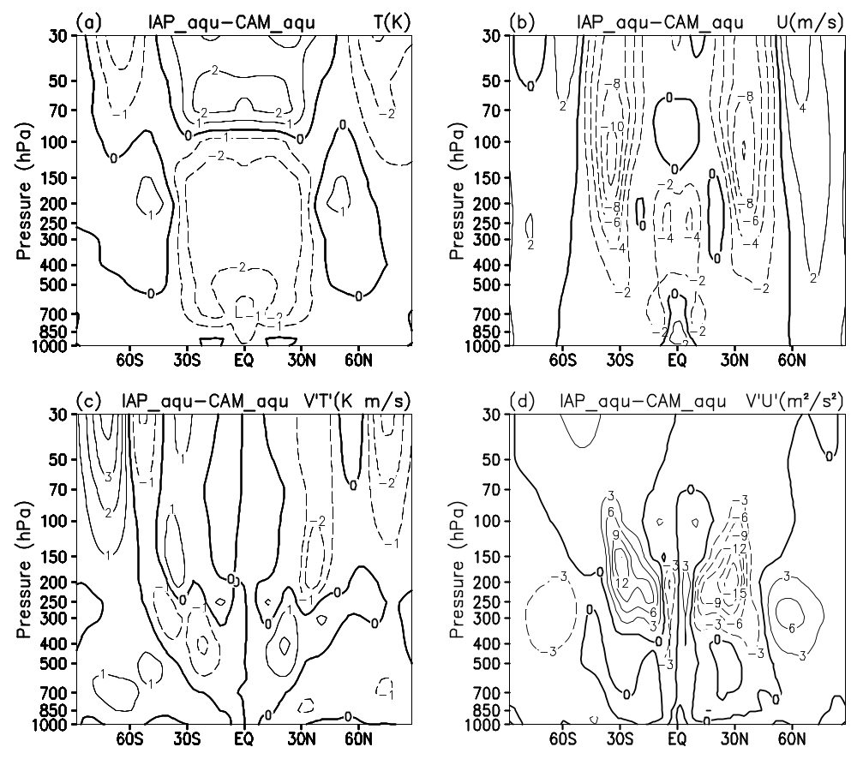
Fig. 10. The difference of zonally averaged annual mean between IAP and CAM from aqua planet tests: (a) temperature; (b) zonal wind; (c) transient eddy heat flux; (d) transient eddy momentum flux. Contour intervals are 0.5 K in (a), 2 m s⁻¹ in (b), 1 K m s⁻¹ in (c), and 3 m² s⁻² in (d).
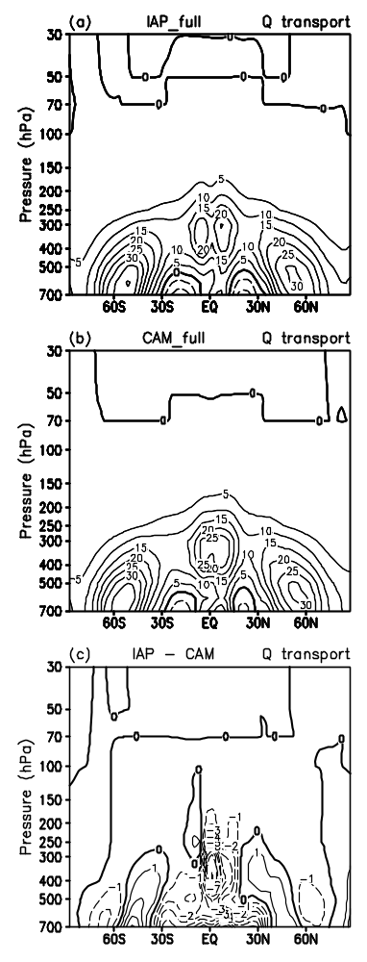
Fig. 11. Zonally averaged annual mean dynamical transport of moisture from (a) IAP and (b) CAM full-physics experiments with realistic boundary conditions, and (c) their difference (IAP - CAM). Contour values are 5 x10⁻² g kg⁻¹ day⁻¹ in (a) and (b), 1 x10⁻² g kg⁻¹ day⁻¹ in (c).

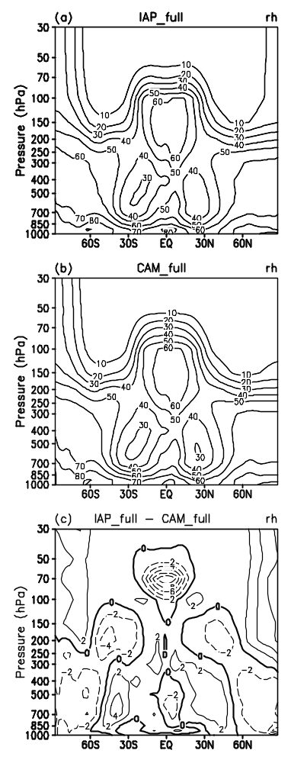
Fig. 12. Same as Fig. 11, but for relative humidity. Contour values are 10 percent in (a) and (b), 2 percent in (c).

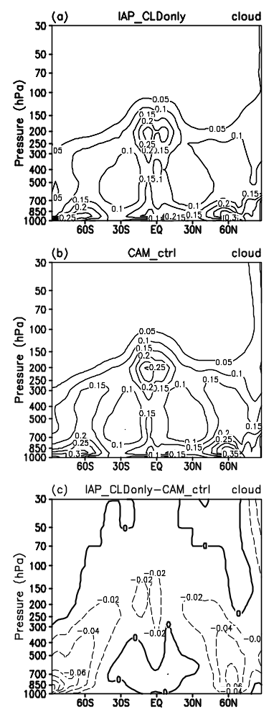
Fig. 13. Cloud fraction used in experiment (a) IAP_CLDonly and (b) CAM_ctrl, and (c) their difference (IAP_CLDonly - CAM_ctrl). Contour values are 0.05 in (a) and (b), 0.02 in (c).

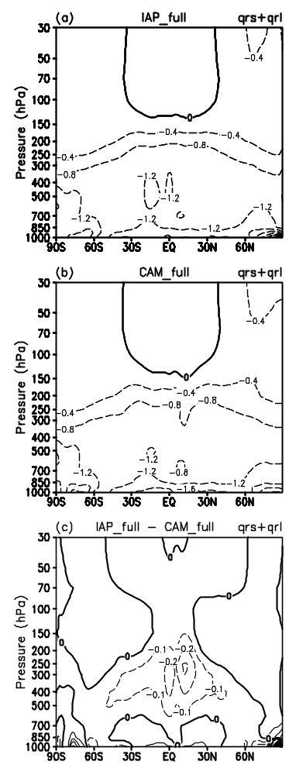

Fig. 14. Zonally averaged annual mean radiative diabatic heating rate (qrs and qrl for shortwave and longwave radiative heating respectively) from (a) IAP and (b) CAM simulations, and (c) their difference (IAP - CAM). Contour intervals are 0.4 K day⁻¹ in (a) and (b), 0.1 K day⁻¹ in (c).
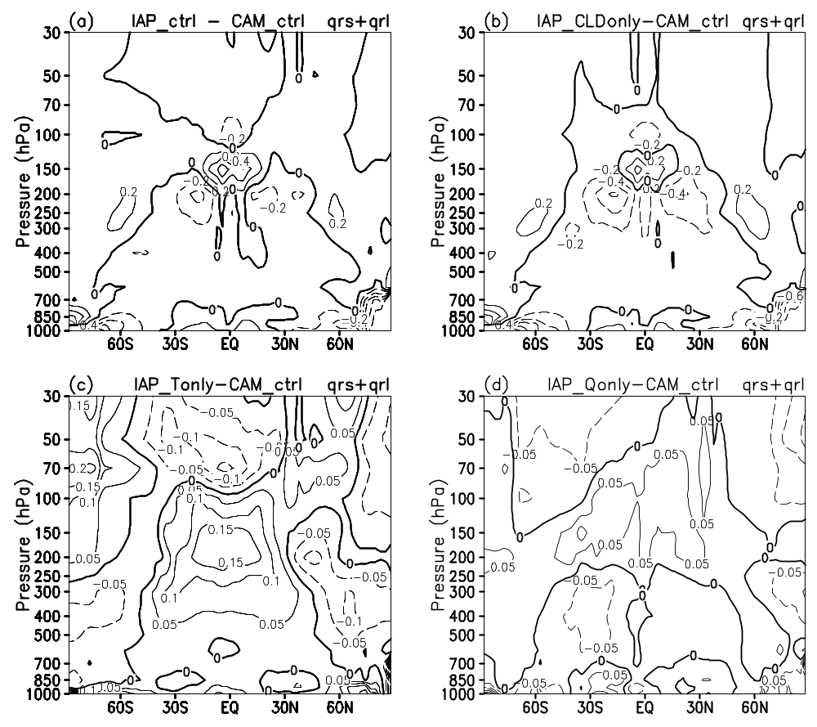
Fig. 15. Differences of radiative diabatic heating rate from the sensitive experiments: (a) IAP_ctrl–CAM_ctrl, (b) IAP_CLDonly–CAM_ctrl, (c) IAP_Tonly–CAM_ctrl, (d) IAP_Qonly–CAM_ctrl. Contour intervals are 0.2 K day⁻¹ in (a) an (b), 0.05 K day⁻¹ in (c) and (d).

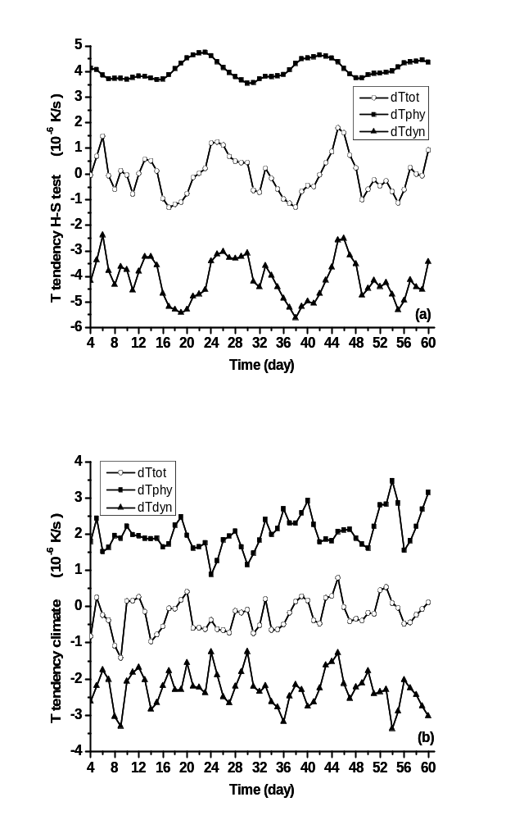
Fig. 16. Evolution of heating rate from the IAP model in (a) Held-Suarez test and (b) climate simulation in troposphere (150 hPa – 1000 hPa) at low latitude (30°S - 30°N). Solid square: diabatic heating rate, solid triangle: adiabatic heating rate, hollow circle: total heating rate. Unit: 10⁻⁶ K s⁻¹

